Trinity: A Stable Coin Lending Protocol Using Decentralized Credit Default Swaps (Part I)
Akshit Vig¹ Kota Harsha Surya Abhishek^{2 *}Shyam Mohan J S³
¹ CEO, SovereignX (Awaiting for Approval), India.
² Blockchain Developer, Rapid Innovation, Noida, India.
³ Assistant Professor, Dept. of CSE, GITAM University, Bengaluru, Karnataka, India.
akshithvig0@gmail.com
khsabhishek1335@gmail.com
jsshyammohan@gmail.com
Abstract
Any business or enterprise transaction happens in currency, either in physical or digital mode. We are currently seeing deterioration in value of our transactional currencies leading to reduction in capital efficiency across all the asset classes. Thus, it is necessary that there is a store of value which is relatively volatile but inherently stable. The stable coin is pegged with our transaction currency like dollars/Rupees to lend it stability and psychological measure of value backed by our understanding of purchasing power of transactional currencies. However, the stable coin also allows the holders to capture the deterioration in purchasing power of transactional currency adding volatility to the process. This volatility works as a hedge against the loss in value of transactional currency.
We propose a novel stable coin (Trinity), a lending platform offering a Loan to Value Ratio (LVR) of 100%. Trinity is a combination of decentralized derivative instrument Credit Default Swaps (CDS) and collateral options to manage the risks and provide adequate incentives for every stakeholder. Trinity is capital efficient backed by strong counterparties to ensure trust in the system. We have devised unique mechanisms to ensure risk is limited to parties who are looking for outsized or more than usual returns on their investment. Trinity acts as a lending protocol that enables 100 % LVR to crypto users. Apart from these features, we have tried adding features to Trinity, managing the risks related to collateral using CDS. The protocol ultimately ensures high capital efficiency of the assets deposited and brings a stable coin which caters to both retail and institutional needs of returns and risk tolerance capacity.
Keywords: Crypto, Credit Default Swaps, Loan to Value Ratio.
- Introduction
We are currently seeing deterioration in value of our transactional currencies leading to reduction in capital efficiency across all the asset classes. Thus, it is necessary that there is a store of value which is relatively volatile but inherently stable. The stable coin is pegged with our transaction currency like dollars/Rupees to lend it stability and psychological measure of value backed by our understanding of purchasing power of transactional currencies. However, the stable coin also allows the holders to capture the deterioration in purchasing power of transactional currency adding volatility to the process. This volatility works as a hedge against the loss in value of transactional currency.
There was a time of the Free Banking Era when anyone could print their own currency and in which there was no government interference of any kind. The free-banking laws specified that a state banking authority determined the general operating rules and minimum capital requirement, but no official approval was required to start a bank. However, this issued new currency also requires the backing of government bonds. These state bonds at that time were not fully riskless but banknotes issued against the same were at par value of bonds. So, Banks were able to issue a $100 banknote by depositing a state bond with a market value of $90 but par value of $100) [1].
There are three reasons behind minting stable coins:
1. They want to stay long in their volatile asset but also not lose out on other opportunities which are coming in this fast growing Defi space. Since, there have been a lot of platforms and yield farms coming out every instant so taking leverage against your capital to take benefit of these other yields is highly enticing. Hence, people borrow stable coins against their volatile asset to explore other yields in the market (2)
2. Stable coin as an asset has a wide acceptance across all the new and established platforms. New platforms prefer stable coins because they do not want their platform to be affected by some external risk factors or broad Defi volatility. Established platforms prefer stable coins so that they can diversify their TVL (Total Value locked) to stable assets which will grant backing to their governance tokens or their utility tokens. Stable coin backing is similar to cash equivalents backing which commands highest trust among the user-base.
3. Users want to take advantage of peg off balance especially when stable coin value in market is above peg. This way they can borrow stable coins at 1 USD/Rupee from the protocol and sell it at market price of > 1 USD to make some gains. This is where arbitrageurs come into play which is highly desired by any platform to bring stability.
Our aim through ‘Project Trinity’ is not to be oblivious of this reality and try to stay close to above core user tendencies as much as possible. We don’t want our protocol to just mint some stable coins by exchanging some volatile crypto just because people want to go riskless. This will make the protocol highly capital inefficient. As we will then be shorting the very asset (ETH or SOL) on which we are building our Defi protocol.
The proposed work tries to provide an opportunity for users to go riskless but in the process do not lose out on their volatile crypto and always be long on the base layer assets.
This chapter is categorized into the following sections:
Section 1: Introduction
Section 2: Background and Related Work
Section 3: Stable Coin - Challenges
Section 4: Problem Statement
Section 5: Proposed Work – The Trinity Project
Section 6: Working of the Protocol
Section 7: Risk Management and Protocol Tokens.
- Background and Related Work
Some of the post popular stable coins in the market are USDT (Tether) and USDC (Circle) and both of them are centralized and backed by Proof of Reserves. A lot of crypto companies pay their employees’ salaries in USDT and USDC and that is also the preferred option among employees. As the value of the USDT is fully backed by fiat currencies so the peg always remains stable and you will always be redeemed $1 for $1 stable coin.
Other stable coins are over collateralized stable coins like Maker Dai which has a native blockchain cryptocurrency like ETH or other established projects tokens as their collateral and stable coins are minted at the Loan to Value ratio of 60% or below mostly. These have gained the most adoption due to their over collateralized nature which makes the protocol less susceptible to default and stable coin also doesn't lose peg widely. There are interest rate mechanisms put in place to manage the demand and supply of stable coins in the market which in turn helps in managing the peg of stable coin to $1[4].
There are fully algorithmic stable coins which are fully backed by on-chain algorithms with an algorithmic rule which manage the supply and demand of stable coins and asset backing them. Both of them can be burned and minted algorithmically to ensure a 1:1 peg.
Then there are partially collateralized and partial algorithmic stable coins like FRAX. Their collateral consists of established blockchain projects like ETH and protocol tokens in a ratio which varies based on the supply and demand of stable coins which affects the stable coin price. If the stable coin price is above peg then there is higher demand for the stable coin which can be utilized by protocol to increase the percentage of their own protocol token as backing for the stable coin minted, leading to adoption of their token widely and increase in price of token. This in turn increases the market capitalization of the project and broader success and strength of protocol.
There are stable coins which just mints stable coin in return for supplying native blockchain assets like ETH or established project tokens. These projects have these deposited assets in their balance sheet which are volatile assets. Any change in value of these assets is compensated by minting of protocol tokens which are sold or bought as per the decrease or increase in asset value at a particular discount.
Till now there have been depegging in all the 4 scenarios mentioned above with major bank runs in algorithmic stable coins and partially collateralized stable coins. Over collateralized stable coins have faced depegging during periods of high collateral volatility which affects the auction of collateral assets at a discounted price. Even centralized stable coins like USDC backed by Proof of reserves had a depegging of more than 10% due to their reserves being affected in banks which got bankrupt due to bank run. Sometimes, the reserves are being utilized in government bonds or other assets which decreased in value leading to fall in reserves.
- Stable Coin - Challenges
Existing collateralized lending protocols and algorithmic stable coins have below issues
- These protocols have a low capital efficiency — DEFI lenders will require collateral over the value of loan so that if the value of borrowed asset drops or the value of the collateral drops, the lender still has cushion in the form of excess collateral allowing the lender to retain their initial principal. This helps in saving the protocol from insolvency but it also limits the amount of the capital that can be borrowed
- Protocols need to constantly monitor the market to set an efficient Liquidation discount — some protocols like Maker and dYdX use an auction mechanism where liquidators bid with increasing amounts of the protocol currency/borrowed asset to liquidate under collateralized accounts. These bidders will be able to get the collateral at a discount named a LD (Liquidation discount) and then sell the collateral back in the open market at the market price and thus pocketing the profit. However, there occurs slippage in the decentralized exchanges like Uniswap which varies with the Liquidation size. This slippage might lower or eliminate the arbitrage while selling the collateral. Thus, these protocols need to constantly monitor the market and re-evaluate their Liquidation discount (LD) to both ensure overpaying of collateral when the market rate is lower as well as ensure not underpay when the market rate is higher which will lead to no one bidding for Liquidation leading to insolvency risks
- Algorithmic stable coins backed by another stable coin - These stable coins are majorly backed by a stable coin asset which doesn’t fulfill the need of users to stay long in their current crypto asset and capture the yields through price appreciation in them.
The proposed work tries to solve these issues.
- Problem Statement
The above challenges have motivated as to work on the proposed work called Trinity. Some of the problems faced in real-time are given below:
- There is a need to create a stable coin which is highly capital efficient with strong backing by the counterparties to ensure trust in the system is maintained.
- Current stable coin protocols have not designed good incentive and user-friendly mechanisms for their borrowers. Borrowers have to monitor their collateralization ratios to avoid risk of getting liquidated. This limits the borrowing capacity to a lower Loan to value ratio so that the borrower has some leeway to manage risk of liquidation. This decreases the capital efficiency of the protocol. Although there are projects out their which through some subscription fees provides services of maintaining the collateral ratios but it introduces another overhead on top of the borrowing fees
- Current Stable coin does not provide downside protection of borrower’s collateral. So, during bearish times, there is a higher risk of collateral liquidation leading to less utilization of these projects leading to less minting of stable coins which can have a ripple effect on the strength or crypto economics of these projects.
- Current stable coin projects have not built a capital efficient way to manage liquidations with incentive structures not attractive enough for liquidators. The best way now is create a readily available pool of stable coins which will be utilized to manage liquidations at a particular discount. These stable coins can be utilized in a better way through a robust incentive structure.
- Proposed Work - The Trinity Project
Project trinity is focused on creating a stable coin that will work as a competitor to dollar and other currencies across the world. With hyperinflation coming, it is necessary that there is a store of value which is relatively volatile but inherently stable. Also, it is being hypothesized that due to excessive printing of dollars by the Federal Reserve in the USA and ending the long term debt cycle could result in excessive depreciation of dollars and loss in its purchasing power. Our stable coin will capture that purchasing power and will work as a hedge against loss in dollar value. ‘Project Trinity’ is a stable coin protocol with the aim to provide the best capital efficiency to every participant involved in the protocol. The project has 3 components as mentioned below:
- Stable coins - These are issued/minted upon locking of collateral like ETH. The LTV (Loan to Value) ratio will be 100%.
- Decentralized CDS (Credit Default swaps) - The second part of trinity are Credit Default Swaps. Depositors can enter in CDS with the protocol and can get regular funding payments apart from the interest rates which they earn by depositing their stable coins on protocol. Participants can earn more than 100% APY over and above the meager interest rates they receive from just depositing their assets. The CDS owners will also act as can also avail the service of option premiums by which their assets will be readily available in case of default by the borrower. They will be compensated with option premiums in return for the same.
- Collateral options - The collateral options are the source of fees for CDS owners. The idea behind collateral options is to give an option to the borrower for creating lossless strategies. In traditional finance, people buy options to hedge their downside and create a limited loss strategy. The same ideology will be used here but with the difference that your upside will also be maintained as the collateral options are a form of call options which allows the borrower to earn all the upside above a particular strike price. As the borrower enters into the contract with the protocol and takes loan against Ethereum or any other collateral then simultaneously another contract will get active where upon paying an upfront option price, the borrower can hedge the downside risk.
These three will work together to maintain the peg of stable coin, manage collaterals and defaults. The protocol will have a set of 2 types of user-base with different risk tendencies and different opinions about the market.
- The first type of users will be borrowers who want to mint stable coins and be also long the volatile crypto asset which they hold. These users also want to achieve the maximum capital efficiency for their deposited capital. To achieve the same, the users will be able to mint and borrow the stable coins against their deposited capital at the maximum LTV ratio of 100%.
- The second type of users will be something called Credit Default swap owners. Credit Default Swap (CDS) allows one to swap the credit/default risk in exchange for some periodic fixed fees. In its aim to provide 100% LTV ratio to borrowers, the protocol comes to face the credit/default risk when there is a decrease in deposited capital (collateral) value. Thus protocol will protect itself against these credit risks with the help of CDS owners. The protocol will swap the credit risk from itself to the CDS owners. These users will deposit the stable coins in CDS contracts. The stable coins deposited will be acting as a counterpart and their capital will be utilized to counter the credit risk generated on decrease of collateral value. These CDS owners' capital will be locked and in return they will be compensated with a combination of upfront fees and periodic fees which will help them in achieving returns near to 100% APY.
  - Option Fees exchange among the participants
The fees will be given by borrowers to CDS owners and will be achieved through an options derivative. The protocol will also have a ‘delta neutral contract’ where borrowers' capital and CDS capital will take a short and long position respectively. This will help in achieving a downside protection on borrower’s capital and will also help the protocol to capture an upside of the borrower’s capital and utilize that upside to provide excessive returns to CDS owners and borrowers as well. For the initial few years, the Protocol parameters will be handled by our core team so as to ensure stable coin peg is maintained and appropriate incentives are created. We will try to automate most of the parameters over the course of this stabilization period in order to achieve an equilibrium state where the protocol runs smoothly.
- Working of the Protocol
The functional model of the proposed work is shown in figure 1.
  - Stakeholders in Protocol
1. Borrowers – Borrows stable coin by depositing acceptable volatile assets (Ethereum) as Collateral
2. Credit Default Swap owners – Deposits stable coin which is utilized by system to provide downside protection for the ETH deposited by borrowers
  - Tokens in Protocol
1. Stable coin
2. Option
3. Hedging/ Bonds Token (generated when CDS owner loses money)
The Borrower borrows stable coin against collateral deposited. Let’s assume the collateral deposited is Ethereum. The Collateral Ethereum is deposited into the Ethereum Vault. On the other side, CDS owner deposits stable coin to be utilized in case of borrower’s default. Protocol now in order to give downside protection of collateral to borrowers will engage in a short position using ETH in the ‘ETH vault’ on the underlying asset i.e. ETH price. On the other side, Protocol will take CDS stable coin deposits and put them in a long position on the ETH/USD price. Now, if the ETH value decreases, the short position will profit by equivalent increase in value. The value is captured by deduction of the same amount from the long position. Also, If ETH value increases, the long position will profit by an equivalent increase in value after deduction of the same amount from the short position. However, due to the rise in ETH price in ETH vault, it creates a net neutral strategy for short position holders thus offering them downside protection. Thus, we achieve our objective of creating a delta neutral strategy by providing downside protection to borrowers as well as protocol during the decrease in collateral (ETH) price. Now, the borrowers don’t have to worry about the confiscation of their collateral due to breach in LTV (Loan to Value) ratios. They also are now able to generate yield during bearish times as their collateral value is not decreasing.
However, by creating this delta neutral strategy, we have also created a limitation in capturing the upside of collateral i.e. increase in price of ETH which is very dear to borrowers and one of the big reasons for them not letting go of their collateral. So, we will be solving this issue with the help of a collateral option’s mechanism that is illustrated in the later sections. The deposits of stable coin are locked for some duration. Also, the CDS owners will be getting option fees from borrowers in return for offering their stable coin deposits to offer downside protection from borrowers. Since, the fees offered might be less to CDS owners in comparison to the downside protection offered, we will be generating a new token called bond/hedge token which will be given to CDS once they unlock their deposit after 1 month. This bond/hedge token will have a maturity of 6 months. 1 bond/ hedge token is equivalent to 100 stable coins at maturity after 6 months. Therefore, after 6 months the CDS owner can use this bond/hedge token to get the full value (100 stable coins). This bond/ hedge token can also be traded before the maturity with other participants.
  - Components of the Protocol
Borrowing of stable coins
A borrower deposits ETH as collateral and protocol mints equivalent value of stable coin in 100% Loan to Value ratio.
- Track the price of ETH at the time of borrowing to store the USD worth of collateral deposited by the borrower. Every borrower will have its USD worth collateral be stored in the smart contract at the time of borrowing.
- Protocol immediately deposits ETH into the ETH vault and takes a short position on the Delta neutral contract.
- Protocol mints stable coin equivalent to USD worth of ETH collateral deposited
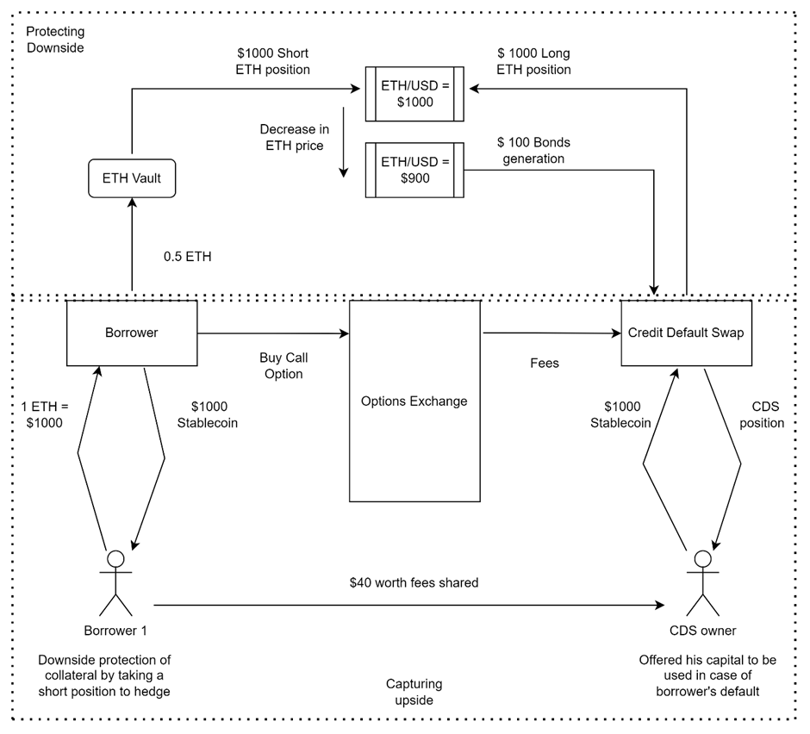
Fig.1.Functional Mechanism of Project Trinity
- Total Debt for a particular Vault = Amount borrowed + Borrowing Fees
At t =0, APR = 12% (APR?)
ETH Price = $1000
Collateral Deposited = 1 ETH = $1000
Stable coin Borrowed, B = $1000
Total Debt at time t = B*(1+APR/n)^t ( Describe n &t)
- Total Debt of Protocol = we don’t need to loop across all the individual vaults to calculate the Total Debt by looking at the individual time for every vault since borrowing. Instead, whenever a new borrower comes to borrow/return the amount then we will just keep on adding and deducting the total borrowed amount. After addition/deduction we will just multiply the amount with the rate for the time since the last borrower came for borrowing/returning the amount.
Therefore, Total Debt to be returned by borrowers = Total Vaults Debt * (1+APR/n) ^t
So, no need to loop across all the vaults every time which can make our contract very complex and time consuming.
Below mentioned are the two scenarios where ETH price increases and decreases to highlight the effect on borrowers, CDS owners and protocol deposits
Borrowers - B1, B2, B3, B4, B5
Borrower's collateral value at different ETH prices - D1, D2, D3, D4, D5.
ETH price incrementing by 100USD increment
Table 1.Change in Borrower’s positions
ETH Price |  | 1000 | 1100 | 1200 | 1300 | 1400
 | Short Position
 | Borrower | D1 | D2 | D3 | D4 | D5
 | B1 | 1000 | 900 | 800 | 700 | 600
 | B2 |  | 1100 | 1000 | 900 | 700
 | B3 |  |  | 1200 | 1100 | 1000
 | B4 |  |  |  | 1300 | 1200
 | B5 |  |  |  |  | 1400
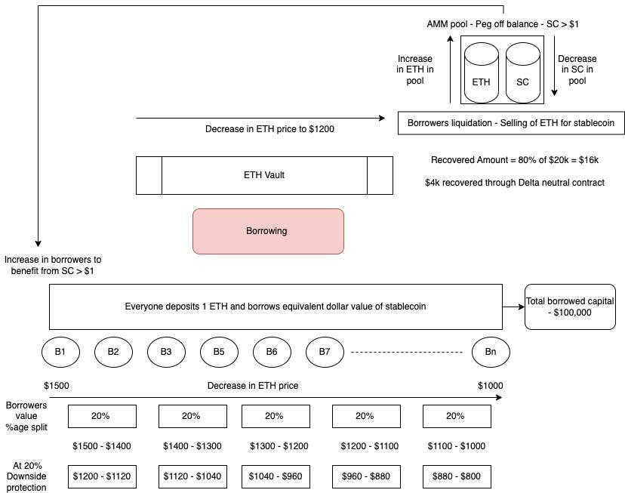
Fig.2.Borrowing Module
1. Change in CDS (Credit Default Swap) holders positions
Table 2. CDS Pool contains 2 CDS holders’ deposits - CDS 1 & CDS 2
Long Position
Pooled CDS positions | D1 | D2 | D3 | D4 | D5
CDS pool value | 2000 | 2100 | 2300 | 2400 | 2500
Bonds minted |  | 0 | 0 | 0 | 0

2. ETH price decreasing by 100USD decrement
Table 3. Change in Borrower’s positions
ETH Price |  | 1000 | 900 | 800 | 700 | 600
 | Short Position
 | Borrower | D1 | D2 | D3 | D4 | D5
 | B1 | 1000 | 1100 | 1200 | 1300 | 1400
 | B2 |  | 900 | 1000 | 1100 | 1200
 | B3 |  |  | 800 | 900 | 1000
 | B4 |  |  |  | 700 | 800
 | B5 |  |  |  |  | 600
3. Change in CDS (Credit Default Swap) positions
Table 3. CDS Pool contains 2 CDS holders’ deposits - CDS 1 & CDS 2
Long Position
Pooled CDS positions | D1 | D2 | D3 | D4 | D5
CDS pool value | 2000 | 1900 | 1700 | 1400 | 1000
Bonds minted | 0 | 100 | 200 | 300 | 400
Total Bonds minted |  | 100 | 300 | 600 | 1000
Here, Bonds tokens are only minted when the CDS owner tries to unlock his/her position. The position can only be unlocked after a certain time threshold and certain protocol parameters conditions like ratio of Total no. of borrowers to Total no. of CDS owners.
Credit Default Swap Entry by Holders
- Each CDS holder will deposit the Trinity stable coins after buying from market in the CDS contract in multiples of $500
- Every CDS holder position will be saved in the contract.
- Total amount will be pooled and a long position is taken on a Delta neutral contract
- The pooled amount will also be utilized to take an option seller position in an options contract on behalf of CDS holders. This way, the CDS holders will be getting the option fees from borrowers.
- The unlocking of CDS holder stable coins will be decided on a combination of fixed term and protocol parameters tracking.
Ratio of CDS holders/ Ratio of Borrowers >=0.2
Above ratio should be greater than 2 to unlock the CDS positions.
Delta Neutral Contract (Downside Protection for Borrowers)
- Delta neutral contract is a contract where 2 opposite positions are taken on the price of ETH/USD.
- One is the short position taken by the borrower’s on ETH/USD and other is the long position taken by CDS holder on ETH/USD
- If the ETH price decreases by 10% then due to the short position taken by the CDS holder, an equivalent USD amount of 10% increase will be added against every ETH in the ETH vault. The same amount will be deducted from CDS long position
- These are synthetic positions and no cash/physical settlement is happening on every change in price after every periodic interval
- Cash settlement only happens if a CDS holder wants to withdraw his amount after a lock-in of 1 month duration is over. At that moment, we will calculate the final balance of the total pooled amount. If the amount is positive than the amount pooled then a fraction of the amount will be deducted and given to the CDS holder.
Calculation of balances of long position and short position
1. Short position (Borrowers)
a. Calculate the quantity of ETH deposited in ETH vault
b. Track the price of ETH in periodic intervals (1 min)
c. If the Price of the ETH in current periodic interval is higher/lower than the previous periodic interval, then the total balance of short position will be deducted by below formula
X = (Total number of ETH in ETH Vault * ETH Price change (Between Periodic intervals)
Short Position Balance = Total Short Position Balance – (Total number of ETH in ETH Vault * ETH Price change (Between Periodic intervals)).
2. Long Position (CDS Holder)
a. Calculate the total amount of stable coin deposited in pool
b. As the price of collateral (ETH) changes, their is a change in the CDS pool long position balance
Total Long Position Balance = Long position balance in previous interval + X (Real)

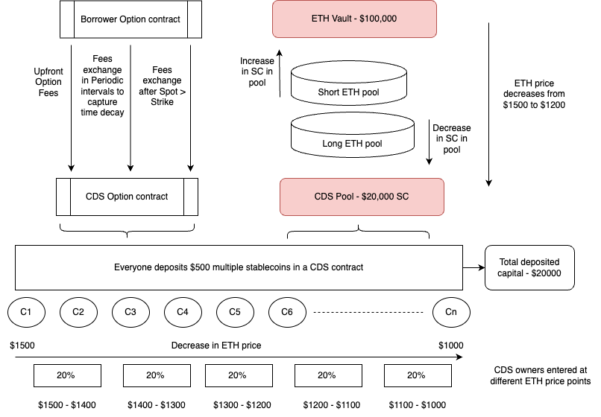
Fig.3. CDS module
Option’s contract
- Option contract is designed to provide an avenue for borrowers to capture an upside on ETH price by buying a call option at a particular strike price
- Option contract also enables the flow of option fees from option buyers i.e. borrowers to Option sellers i.e. CDS holders. This help provide an high yield APY to CDS holder who have deposited their amount to be utilized in providing a Delta neutral position to borrowers
- There are 5 variations of strike prices that can be taken by borrowers – 5%, 10%, 15%, 20%, 25%. It implies that borrowers can buy a call option on ETH price on the above percentage ranges for strike prices only
- The option price will decrease from 5% strike price option to 25% strike price option as per the risks
There are three different approaches of designing an option fees exchange mechanism:
First Approach
- There will be only 5 markets for option prices -
  - Borrowers who bought a call option at 5% strike price will be clubbed together
  - Borrowers who bought a call option at 10% strike price will be clubbed together
  - Borrowers who bought a call option at 15% strike price will be clubbed together
  - Borrowers who bought a call option at 20% strike price will be clubbed together
  - Borrowers who bought a call option at 25% strike price will be clubbed together
- Initially we will start with only a 5% strike price option market. So, all borrowers will be entering in a options contract by buying a 5% strike price option
- Option Price calculation
For a borrower buying a 5% strike price option when ETH price is at $1000 so the strike price is $1050
He pays some Initial Option Fees = 20$
Option Price = Current Option Price * (1+ %change in ETH price from the contract start * 10) - (Time decay affect on Price)
Option Price also changes if some borrower comes in between to sell it’s option at the price going on. So, that seller will be given the increase in option price by deducting the same amount over the left borrowers who are still holding the option implying they are bullish on the option price and thus acting as a counter party to the borrower looking to exit from his option contract.
Second Approach
- Option buyer after engaging in an option contract will be given a NFT depicting his position on 5% strike price. He can then take the NFT and list it in a marketplace to be sold at a particular price.
- NFT buyers can pay the list price and will be given the NFT which they can deposit at our protocol to get the resulting benefits if the ETH price is above the strike price on an expiry date
Third Approach
Option prices with no maturity dates and 5 strike price options
- Borrowers who bought a call option at 5% strike price will be clubbed together
- Borrowers who bought a call option at 10% strike price will be clubbed together
- Borrowers who bought a call option at 15% strike price will be clubbed together
- Borrowers who bought a call option at 20% strike price will be clubbed together
- Borrowers who bought a call option at 25% strike price will be clubbed together
Total Option fees = 40% Upfront Payment + Continuous stream of option payments for time decay in option price with no maturity dates
For Instance, ETH spot price = $1000
Borrower deposits 1 ETH as collateral to borrow $1000 stable coin
Borrower takes a call option at 5% strike price with no expiry of maturity date. So, the strike price is $1050
Total fees = Upfront Option Fees + Continuous stream of option payments to capture theta decay + Option Fees to maintain position ( If Spot > Strike)
Total Fees = $10 + $20 (Continuous fees deduction from $20 in 1% percentage points corresponding to theta decay) + (%age Deduction of overall upside as long as the position is kept open)
- Risk Management and Protocol Tokens
The protocol is designed in a way so that we can offer downside protection to borrower on their collaterals and also allow them to capture the upside of collateral. Right now, it’s facilitated with a combination of CDS capital and collateral option as incentives.
However, it's necessary that the protocol has enough flexibility to manage risk by providing appropriate incentives for participants in the form of Protocol tokens. These protocol tokens will be minted and burned only based on participant’s actions. We understand from Traditional finance on the role of time value of money in providing yields to one party whose assets are utilized by a counterparty to manage the project operations. We are also utilizing CDS owner’s assets to manage downside risk of collateral in our protocol. In return they are provided with some upfront fees and a continuous flow of fees for time decay in options. Protocol Tokens will be utilized as a risk management tool for both protocol and CDS owners.
  - Approach 1
If we look at current decentralized lending markets like Compound Finance then we notice that stable coins offer a supply APY 20-40X higher than APY on volatile assets like ETH. This yield offered is even higher for tokens with yield farms running.
Thus, when someone deposits Ethereum to borrow stable coins then he/she has the potential to earn higher yields by utilizing their stable coins efficiently. Even after deducting borrows fees, the yields offered are higher on stable coins because of their non-volatile nature.
Our protocol has a downside protection built in through our Delta neutral function. However, our protocol should have flexibility to manage risk through reducing our reliance on collateral assets volatility. By providing incentives through protocol tokens to participants we can diversify risk from collateral assets to protocol tokens. These protocol tokens mint function will get activated when the borrower’s collateral has fallen down to 10%. The number of protocol tokens minted will be twice the fall in collateral value. So, if the collateral has fallen down to 10% then the total token minted value should be equal to 20% of collateral value. These minted tokens will be provided to the borrower on returning the stable coins borrowed. As the provided tokens are double the value of loss in collateral so it acts as an incentive for the borrower to earn an upfront yield. The higher yields which the borrower would have earned by locking or staking their stable coins on some protocol can be compensated through the upfront tokens earned on returning the borrowed stable coin.
Thus, the protocol is able to diversify the risk through minting of protocol tokens and using that as incentive for borrowers to timely return their borrowed capital. This also allows the protocol to protect the CDS capital from getting depleted away in the delta neutral function.
The CDS owners are also taking a fair amount of risk in return for outsized returns in form of option fees. The participation of CDS owners is right now solely dependent on their view of the volatility of collateral assets. If the volatility of the collateral asset is small then they will be in a better off position through higher returns from option fees. However, if the volatility of collateral assets is high then their returns have a higher probability of getting hit. Thus, by diversifying the risks from collateral volatility to our protocol tokens, we have a higher flexibility of managing risks in the protocol. The protocol will mint tokens which will be distributed after some term or time duration to CDS owners. This will act as yield on locking of CDS capital for higher durations with the protocol.
How protocols manage against algorithmic risks?
- As the protocol LTV is 100% so some users might try to take the loan in stable coin to buy ETH and again take the loan against this bought ETH. Users might try to do the same continuously in order to game the system.
Here, firstly as some fees are deducted from the loan given in stable coins so the loan value is around 95%. Thus, a scenario of opening borrowing positions repeatedly by utilizing the borrowed SC amount will not be able to affect the system. Ultimately the value is being returned to the system.
The only systemic risk could be that if all these borrowing positions collateral fell in value then it would affect our CDS pool
  - Managing Liquidation in Protocol
Method 1
We have a set of borrowers Br = { b1,b2,b3,b4…………..bn)
Where bi denotes the i-th borrowing position
It is a single collateral lending protocol with stable coin borrowed in a LTV ratio of 100%
Assuming the collateral utilized is ETH, we have all these borrowers coming at different points of time at different ETH prices and borrowing stable coin loan at 100% LTV
So, ETH prices corresponding to these set of borrowers can be denoted as
Er = ( E1, E2, E3,E4…………….En)
Where Ei denotes the ETH price for the i-th borrowing position
The collateral amount will be a fraction or multiple of ETH value with Ci denoting the collateral deposited by the i-th borrower.
The Debt taken in stable coin is equivalent to the price of ETH at a LTV of 100%LTV
As the borrower also needs to engage in an option contract along with the borrowing so the borrower needs to pay some option fees which will be utilized for providing downside protection to collateral and capturing ETH upside if the price rises above a particular strike price. We will deduct these fees at the time the borrowing occurs from the Loan value taken by the borrower
These option fees are a combination of upfront fees and fees for taking a perpetual position in the call option. Some of these will be returned after deducting the perpetual call option fees corresponding to the time decay which occurred for the particular borrowing position. The fees will be returned to the borrower in case of an early close of a borrowing position.
The fees will be calculated on the below factors:
- The fees will have a $10 minimum cap
- The fees will be dependent on the strike price of the perpetual call option. Fees will be higher for a higher strike price option.
- Upfront fees will be calculated as per the percentage of downside protection offered to the collateral amount. At the start of the protocol, we will be offering 20% downside protection.
Upfront fees = 10% * 20%* Ci*Ei
Perpetual Option Fees
- Borrowers who bought a call option at 5% strike price will be clubbed together
40%* (Strike Price of ETH - Ei)
- Borrowers who bought a call option at 10% strike price will be clubbed together
30%* (Strike Price of ETH - Ei)
- Borrowers who bought a call option at 15% strike price will be clubbed together
20%* ( Strike Price of ETH - Ei)
- Borrowers who bought a call option at 20% strike price will be clubbed together
10%* (Strike Price of ETH - Ei)
- Borrowers who bought a call option at 25% strike price will be clubbed together
5%* (Strike Price of ETH - Ei)
The perpetual option fees will have a time decay deduction of fees every day from the perpetual option fees
Time decay = 0.1$ + 10% * (ETH price change every day)
  - Liquidation management
We manage Liquidation by minting protocol tokens. However that does not mean that we wait for Liquidation to happen and then take action. We will take proactive action to protect the protocol against any Liquidation or strive to earn some yield till the Liquidation happens. This will happen in 2 ways
- Earning yield from collateral deposited - We will split the collateral value in 2 parts and half of the collateral will be deposited in some other protocol to earn yield and half of the collateral will be kept here to offer downside protection in our See - Saw function
- Minting of protocol tokens at various stages - Minting of protocol tokens will be done when the collateral value is 90% of the borrowed amount and when the collateral value has touched 80% of the borrowed amount. When the collateral value touches 80% of the borrowed amount then we give them protocol tokens in return for stable coins. We will apply some Liquidation discount before giving protocol tokens. This mechanism will ensure that we do not have to take our collateral back from an external protocol which might charge us some fees and losing out on yield on the collateral deposited
If Di is the debt in stable coin taken by the borrower bi then at 100% LTV
Di = Ci * Ei
Rt denotes the value of collateral ETH at time t
So, Health of the borrowing position,
Hi = ( Ci * Rt ) / Di = (Ci *Rt) / ( Ci * Ei) = Rt / Ei
Health varies from
Protocol tokens will be minted at different stages
- When Hi approaches 0.9, the protocol tokens will be minted based on below formula
If market price of protocol tokens = Pm
Protocol Tokens = [( Ei - Rt) * 2] / Pm
- When Hi approaches 0.8, the protocol tokens will be minted again
We will apply a Hypothetical Liquidation discount (U) to come at the value of the protocol tokens minted for Liquidators
Protocol Tokens = [0.1 * ( Ei - Rt) ] / Pm
*Here Hi of 0.9 & 0.8 are dependent on the ETH volatility and CDS volumes/Borrower volumes
Example
Assuming the current market price of ETH, Rt = $1000
The borrower, bi puts 1 ETH as collateral. In return the protocol mints $1000 Trinity SC
So, here Ci is the collateral as a multiple of ETH = 1
Also, Ci*Ei = 1*1000 = $1000
The borrower also chooses the 5% strike price i.e. $1050
So, the option price for borrower = Upfront Option fees + Perpetual option fees
= 0.1*0.2*Ci*Ei + 0.3*(Strike Price - Ei)
= 0.1*0.2*1000 + 0.4*(1050-1000)
= 20 + 20 = $40
So, out of 1000 Trinity SC minted, we will take 40 SC as Option Fees leaving the borrower with 960 SC
Different scenarios are given below:
- ETH fell to $950
Health of borrowing position, Hi = 0.95
If borrower decided to come and return $1000 SC then he will get his ETH and $50 SC
So, in essence, the borrower should be returned only $950 SC and will get his ETH back
CDS
- ETH fell to $900
So, here Hi = 0.90
Let’s, Protocol tokens, Pm = $2
The protocol will mint Protocol tokens = [( Ei - Rt) * 2] / Pm
= [(1000 - 900) * 2]/ 2
= 100 Protocol tokens
Here, if the borrower decided to come and return $1000 SC then he will get his ETH back after a 3 month time period but he will get 100 Protocol tokens immediately.
In essence, the borrower should return only $900 SC and he will get his 100 Protocol tokens
- ETH fell to $850
Here Hi = 0.85
Here, if the borrower decided to come and return $1000 SC then he will get his ETH back after a 3 month time period but he will get those earlier minted 100 Protocol tokens.
In essence, the borrower should return only $850 SC and he will get his 100 Protocol tokens
- ETH fell to $800
Here, Hi = 0.8
Here, the borrower collateral assets will now become protocol assets. So, Protocol will become the owner of ETH.
The earlier 100 protocol tokens + 10% more Protocol tokens will be given to Liquidator who will give 200 SC to protocol in return for Protocol tokens
So, Liquidator will get = [0.1 * ( Ei - Rt) ] / Pm
= 100 + 0.1* (1000 - 800)/2
= 100 + 10 = 110 Protocol tokens
Liquidator will get = 1.1 * [( Ei - Rt) / Pm] it will be a direct call from the user (depositor of that particular index cannot be a Liquidator/user).
  - Calculation of CDS depositor returned amount on withdrawal
We should be able to know the total amount to be returned to the CDS depositor after a particular time period.
So, the process of calculation of the exchange of funds between ETH pool and CDS pool will be done after every CDS action or borrower action
As soon as a CDS deposits some funds into our platform, then we will identify
- Current ETH market price, Er
- Amount of CDS funds deposited/Total CDS deposited funds till now (Cd/C)
- Total number of ETH holdings in our ETH pool
We will then calculate the current value of CDS funds in our protocol
Total CDS Deposited Funds = C
CDS deposited funds = Cd
CDS current funds = Cr1
So, Cr = Cd + (Cd/C)*(Er - Ei)*(Total Eth Holdings)
We will calculate the division of exchanged funds among the total CDS depositors through the above formula. As soon as there is a new depositor or new borrower or any sort of new event which takes place then the value of different figures in the formula will change. This will then change the division percentage of exchanged funds after the new event.
Thus, Cr2 = Cd + (Cd/C)*(E_{r}- E_{i+1}) * (Total ETH Holdings)

Table 4. CDS Depositors Calculation
Day | Total ETH | Initial ETH capital | ETH price | Initial CDS amount | CDS Pool | CDS depositors | Total | Net value of CDS Pool
1 | 51 | 50000 | 1000 | 10000 |  | 1000 | 11000 | 11000
2 | 52 |  | 1010 |  | 510 | 1000 | 12000 | 12510
3 | 53 |  | 1020 |  | 1030 | 1000 | 13000 | 14030
4 | 54 |  | 1030 |  | 1560 | 1000 | 14000 | 15560
5 | 55 |  | 1040 |  | 2100 | 1000 | 15000 | 17100
6 | 56 |  | 1030 |  | 1550 | 1000 | 16000 | 17550
7 | 57 |  | 1020 |  | 990 | 1000 | 17000 | 17990
8 | 58 |  | 1010 |  | 420 | 1000 | 18000 | 18420
9 | 59 |  | 1000 |  | -160 | 1000 | 19000 | 18840
10 | 60 |  | 950 |  | -3110 | 1000 | 20000 | 16890

Table 5. CDS Depositors Values obtained - Day wise
 | Day 2 | Day 3 | Day 4 | Day 5 | Day 6 | Day 7 | Day 8 | Day 9 | Day 10
CDS 1 | 1046.4 | 1043.3
CDS 2 |  | 1043.3
CDS 3 |  |  | 1040.8
CDS 4 |  |  |  | 1038.6
CDS 5 |  |  |  |  | 963.3
CDS 6 |  |  |  |  |  | 965.0
CDS 7 |  |  |  |  |  |  | 966.5
CDS 8 |  |  |  |  |  |  |  | 967.8
CDS 9 |  |  |  |  |  |  |  |  | 844.7

So, after every event, the reward percentage split changes which require us to calculate the split of rewards between 2 deposit intervals among all the CDS depositors till that moment. This exercise will be too computationally intensive for the smart contract considering there might be 100s of thousands of CDS depositors. Also, calculating the reward split before every new CDS deposit would delay the transaction completion time and considerably affect the user experience.
In order to manage the above situation, we will be maintaining a record of reward split for only one standardized deposit amount. For the start, we have considered that deposit amount to be $1000. So, before every new CDS deposit transaction, we will calculate the proportionate reward for $1000 worth of deposits and keep on updating the total amount after every transaction. This will allow us to calculate the final amount to be given back to CDS when he/she tries to close the CDS position. The total amount for the particular CDS will be a fraction/multiple of the current total amount of the standard $1000 deposit figure.
Thus, we have been able to identify the value accrued to a CDS position during the time of withdrawal which is one of the critical values to calculate from the operation of our See - Saw contract.

Appendix
We are adding a financial model where we tested our model. We have built the model for 10 borrowers and 10 CDS depositors who are coming at different points of time at different ETH prices. The model could be extrapolated to 1000s of borrowers and CDS depositors. We have tried to calculate the change of P/L on the CDS pool with the change in ETH price. We have also calculated the split of P/L among all the CDS depositors on every new event like new CDS position opened, new borrower entered, borrower closing the position or any contract call by external user. This is basically the core model of our See-Saw function which is the function where assets move between ETH Vault and CDS pool with change in ETH prices.
Table 1. Borrowers and 10 CDS depositors at different ETH prices
Day | Total ETH | Initial ETH capital | ETH price | Initial CDS amount | P/L of CDS Pool | CDS depositors | CDS Depositor %age of ETH price
1 | 51 | 50000 | 1000 | 10000 |  | 1000 | 1
2 | 52 |  | 1010 |  | 510 | 1000 | 0.9900990099
3 | 53 |  | 1020 |  | 1030 | 1000 | 0.9803921569
4 | 54 |  | 1030 |  | 1560 | 1000 | 0.9708737864
5 | 55 |  | 1040 |  | 2100 | 1000 | 0.9615384615
6 | 56 |  | 1030 |  | 1550 | 1000 | 0.9708737864
7 | 57 |  | 1020 |  | 990 | 1000 | 0.9803921569
8 | 58 |  | 1010 |  | 420 | 1000 | 0.9900990099
9 | 59 |  | 1000 |  | -160 | 1000 | 1
10 | 60 |  | 950 |  | -3110 | 1000 | 1.052631579
 |  |  |  |  |  |  | 9.896899947

Table 2. Total/Net ETH Vault and Total/Net CDS Pool with Pool ratios
Initial CDS amount | Total CDS pool | Net value of CDS Pool | P/L of ETH Pool | ETH pool at market price | ETH Pool with P/L | Net ETH pool value | Ratio | Inverse of Ratio
10000 | 11000 | 11000 |  | 51000 | 51000 | 51000 | 0.216 | 4.636
 | 12000 | 12510 | -510 | 52520 | 52010 | 52010 | 0.238 | 4.198
 | 13000 | 14030 | -1030 | 54060 | 53030 | 53030 | 0.260 | 3.853
 | 14000 | 15560 | -1560 | 55620 | 54060 | 54060 | 0.280 | 3.575
 | 15000 | 17100 | -2100 | 57200 | 55100 | 55100 | 0.299 | 3.345
 | 16000 | 17550 | -1550 | 57680 | 56130 | 56130 | 0.304 | 3.287
 | 17000 | 17990 | -990 | 58140 | 57150 | 57150 | 0.309 | 3.232
 | 18000 | 18420 | -420 | 58580 | 58160 | 58160 | 0.314 | 3.180
 | 19000 | 18840 | 160 | 59000 | 59160 | 59160 | 0.319 | 3.132
 | 20000 | 16890 | 3110 | 57000 | 60110 | 60110 | 0.296 | 3.375
Table 3. Annual Volatility
Eth Price | Date | Daily returns | Daily volatility | Annual volatility
1215.480165 | 11/27/22 0:00
1216.120944 | 11/26/22 0:00 | 0.001 | 3.35% | 32.02%
1190.840868 | 11/25/22 0:00 | -0.021
1199.777785 | 11/24/22 0:00 | 0.007
1163.074472 | 11/23/22 0:00 | -0.031
1110.720153 | 11/22/22 0:00 | -0.046
1122.223882 | 11/21/22 0:00 | 0.010
1193.216625 | 11/20/22 0:00 | 0.061
1210.534792 | 11/19/22 0:00 | 0.014
1214.575382 | 11/18/22 0:00 | 0.003
1205.69334 | 11/17/22 0:00 | -0.007
1230.465701 | 11/16/22 0:00 | 0.020
1259.073674 | 11/15/22 0:00 | 0.023
1230.783049 | 11/14/22 0:00 | -0.023
Table 3 shows the ETH price changes over a couple of days. However, we have calculated the daily volatility and annual ETH volatility from 26/07/2022 to 27/11/2022 period by observing the change in ETH price in this 4 month period.
Table 4. Calculation of CDS Amount
S.No | Collateral deposited | Stable coin borrowed at 60% LTV | Collateral value after week | LTV ratio after 1 week | Breach of LTV | Difference | Total amount required from CDS pool
1 | 345 | 207 | 318.53 | 0.65 | 15.88 | 138 | 20818
2 | 236 | 141.6 | 231.56 | 0.61 | 2.67 | 94.4
3 | 156 | 93.6 | 158.58 | 0.59 | -1.55 | 62.4
4 | 803 | 481.8 | 812.90 | 0.59 | -5.94 | 321.2
5 | 258 | 154.8 | 267.45 | 0.58 | -5.67 | 103.2
6 | 224 | 134.4 | 248.15 | 0.54 | -14.49 | 89.6
7 | 851 | 510.6 | 954.78 | 0.53 | -62.27 | 340.4
8 | 371 | 222.6 | 382.68 | 0.58 | -7.01 | 148.4
9 | 912 | 547.2 | 935.88 | 0.58 | -14.33 | 364.8
10 | 287 | 172.2 | 298.99 | 0.58 | -7.19 | 114.8
11 | 911 | 546.6 | 958.09 | 0.57 | -28.25 | 364.4
12 | 441 | 264.6 | 441.18 | 0.60 | -0.11 | 176.4
13 | 723 | 433.8 | 705.52 | 0.61 | 10.49 | 289.2
14 | 890 | 534 | 1055.66 | 0.51 | -99.39 | 356
Table 4 applies a random number generator function for CDS deposit amounts over a time span of 100 days by tracking ETH prices over the same period also. We then calculate the LTV ratios and sum them up the values which breach the LTV ratio beyond a standard industry wide figure of 60% LTV. This gives us the total amount to be required from the CDS pool and by CDS depositors.
Another method of LP tokens minting mechanism to calculate P/L of every CDS position is shown in table 5.
Table 6 describes the total shares left after change in CDS pool total value due to change in ETH price. We are able to calculate the final CDS amount for every open CDS position at any instant of time by looking at the total shares/LP tokens owned by the CDS depositor.
Bonds Tokens
In case, the fees offered is less for CDS owners in comparison to the downside protection offered, we will be generating a new token called bond/hedge token which will be given to CDS once they unlock their deposit after 1 month. This bond/hedge token will have a maturity of 6 months. 1 bond/ hedge token is equivalent to 100 stable coins at maturity after 6 months. Therefore, after 6 months the CDS owner can use this bond/hedge token to get the full value (100 stable coins). This bond/ hedge token can also be traded before the maturity with other participants.
Table 5. LP Tokens Minting Mechanism
Total CDS Deposited by users | CDS Amount Deposited at periodic intervals | Balance of CDS | Shares minted for the CDS deposit | Total shares
10000 | 10000 | 10000 | 10000 | 10000
11000 | 1000 | 11000 | 1000 | 11000
 | 510 | 11510 | 0 | 11000
12000 | 1000 | 12510 | 955.6907037 | 11955.6907
 | 520 | 13030 | 0 | 11955.6907
13000 | 1000 | 14030 | 917.5510901 | 12873.24179
 | 530 | 14560 | 0 | 12873.24179
14000 | 1000 | 15560 | 884.1512221 | 13757.39302
 | 540 | 16100 | 0 | 13757.39302
15000 | 1000 | 17100 | 854.4964606 | 14611.88948
 | -550 | 16550 | 0 | 14611.88948
16000 | 1000 | 17550 | 882.893624 | 15494.7831
 | -560 | 16990 | 0 | 15494.7831
17000 | 1000 | 17990 | 911.9942967 | 16406.7774
 | -570 | 17420 | 0 | 16406.7774
18000 | 1000 | 18420 | 941.8356715 | 17348.61307
17840 | -580 | 17840 | 0 | 17178.73205
18840 | 1000 | 18840 | 962.9334111 | 18141.66546
 | -2950 | 15890 | 0 | 15078.10991
 | 1000 | 16890 | 948.9055954 | 16027.01551

Table 6. Total Shares Left in CDS Pool
Shares minted for the CDS deposit | Total shares | Shares burned | Total Amount during withdrawal | Final CDS Amount withdrawn
10000 | 10000 | 0
1000 | 11000 | 0
0 | 11000 | 0
955.6907037 | 11955.6907 | 0 | 1046.363636 | 1046.363636
0 | 11955.6907 | 0
917.5510901 | 12873.24179 | 0 | 1043.333333 | 1089.857568
0 | 12873.24179 | 0
884.1512221 | 13757.39302 | 0 | 1040.769231 | 1131.028239
0 | 13757.39302 | 0
854.4964606 | 14611.88948 | 0 | 1038.571429 | 1170.279862
0 | 14611.88948 | 0
882.893624 | 15494.7831 | 0 | 963.3333333 | 1132.639282
0 | 15494.7831 | 0
911.9942967 | 16406.7774 | 0 | 965 | 1096.498085
0 | 16406.7774 | 0
941.8356715 | 17348.61307 | 0 | 966.4705882 | 1061.756345
0 | 17178.73205 | -169.8810152 |  | 160
962.9334111 | 18141.66546 | 0 | 967.7777778 | 1038.493408
0 | 15078.10991 | -3063.555554 |  | 2950
948.9055954 | 16027.01551 | 0 | 844.7368421 | 867.3074719

References
- https://country.eiu.com/article.aspx?articleid=1532551136&Country=United+States&topic=Economy&sub_1
- Volatility and the Allegory of the Prisoner’s Dilemma – False Peace, Moral Hazard, and Shadow Convexity, October 2015.
- The Free-Banking Era: A Lesson for Today? Economic Insights, Third Quarter 2016, Federal Reserve Bank of Philadelphia Research Department.
- https://docs.makerdao.com/
- Michael Darlin et.al,”Debt-Financed Collateral and Stability Risks in the DeFi Ecosystem”, arXiv:2204.11107v2 [q-fin.TR] 7 Jun 2022.
- Luyao Zhang et.al,”Optimal Algorithmic Monetary Policy: Blockchain for Digital Money”, https://arxiv.org/ftp/arxiv/papers/2104/2104.07888.pdf.
- AN EVENT STUDY ON THE MAY 2022 STABLECOIN MARKET CRASH, Hong Kong Monetary Authority, Research Memorandum 09/2022.
- Morten L. Bech, Intraday Liquidity Management: A Tale of Games Banks Play, FRBNY Economic Policy Review / September 2008.
- https://compound.finance/markets
- K. Jarno and H. Kołodziejczyk, “Does the Design of Stablecoins Impact Their Volatility?,” Journal of Risk and Financial Management, vol. 14, no. 2, p. 42, Jan. 2021, doi: 10.3390/jrfm14020042.
- Clements, Ryan, Built to Fail: The Inherent Fragility of Algorithmic Stablecoins (October 28, 2021). 11 Wake Forest L. Rev. Online 131 (October 2021), Available at SSRN: https://ssrn.com/abstract=3952045 or http://dx.doi.org/10.2139/ssrn.3952045
- https://hackernoon.com/tokenomics-of-different-stablecoins-ttg33ut
- Antonio Briola, David Vidal-Tomás, Yuanrong Wang, Tomaso Aste, Anatomy of a Stablecoin’s failure: The Terra-Luna case, Finance Research Letters, Volume 51, 2023, 103358, ISSN 1544-6123, https://doi.org/10.1016/j.frl.2022.103358.
- Saengchote, Kanis, A DeFi Bank Run: Iron Finance, IRON Stablecoin, and the Fall of TITAN (July 16, 2021). Available at SSRN: https://ssrn.com/abstract=3888089 or http://dx.doi.org/10.2139/ssrn.3888089
- https://hbr.org/2021/08/stablecoins-and-the-future-of-money
- Hassan, M., Ngow, T., Yu, JS. et al. Determinants of credit default swaps spreads in European and Asian markets. J Deriv Hedge Funds 19, 295–310 (2013). https://doi.org/10.1057/jdhf.2014.1

